Manual Failover:

On primary server:

Use msdb

Go

Select primary_server , primary_database , last_backup_date , last_backup_file , *

From log_shipping_monitor_primary

1. Take a final tail log backup for any transaction not backed up if the transaction log numbers don’t match (by running all three jobs)

2. Disable all three jobs

3. Run the following tail log backup with no recovery on primary server

Backup log [source_db]

To disk = N’C:\Source\Tail.trn’

With no_truncate ,

Noformat ,

Noinit ,

Name = N’Source_db_Full Database Backup’ ,

Norecovery

go

the recovery mode will make the database in a restoring state

4. Copy and paste this last tail log from primary to secondary

On secondary server:

Use msdb

Go

Select secondary_server , secondary_database , last_restored_date , last_restored_file , *

From log_shipping_monitor_secondary

5. Restore last tail log in secondary

Use msdb

Go

Restore log [source_db]

From disk = N’C:\Destination\Tail.trn’

With file = 1,

Nounload

Go

Now this database becomes a live database

6. Start the log shipping process from start making this the primary, and the original primary the secondary

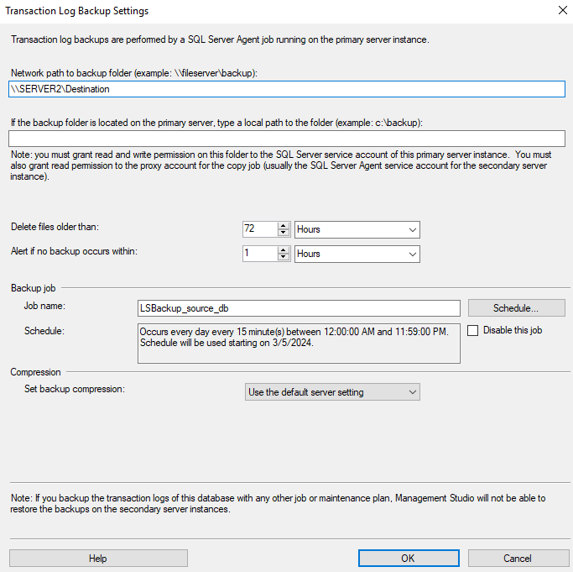

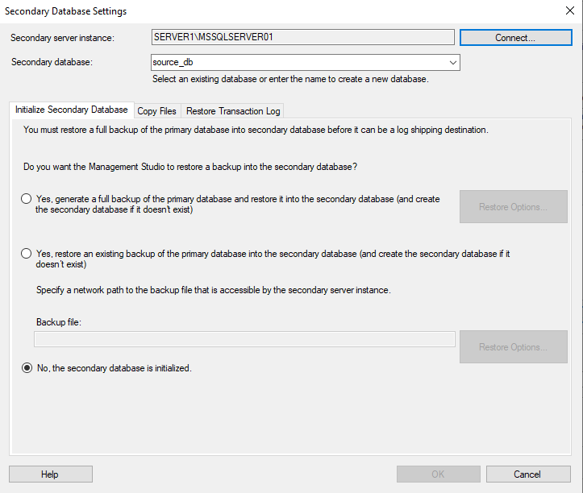

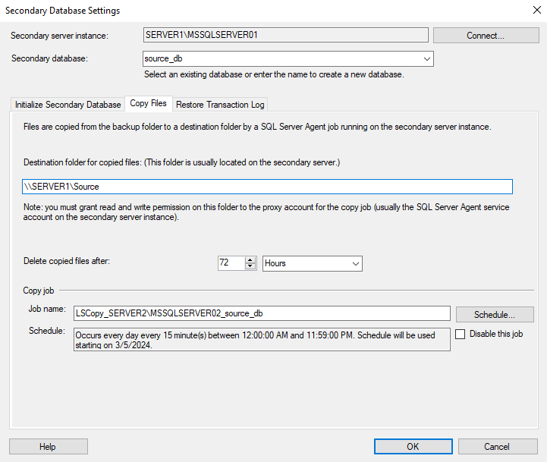

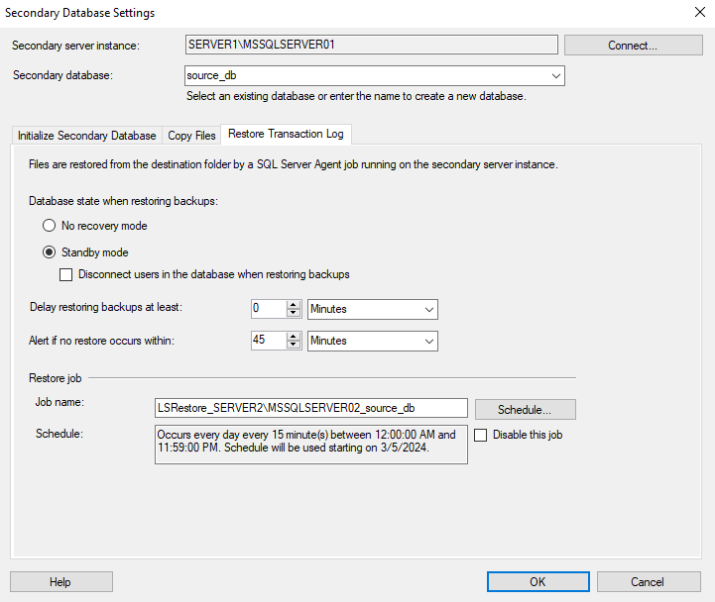

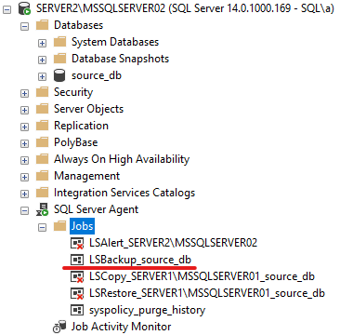

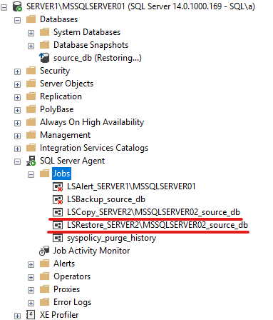

7. Delete old jobs

Now the server2 is primary and the server1 is secondary